Assignment 1
PNR: 260740150018
Name: PRATIK SUNIL ABHANG
Question:
Find the largest element in a list.
Program
print('by default')
list1 = [1, 25, 50, 75, 100]
print('default list:', list1)
print('largest element:', max(list1))
print('\nby user')
list_user = []
n = int(input("enter no. of elements: "))
for i in range(n):
element = int(input(f"enter element {i+1}: "))
list_user.append(element)
print('user list:', list_user)
print('largest element:', max(list_user))

Input and Output
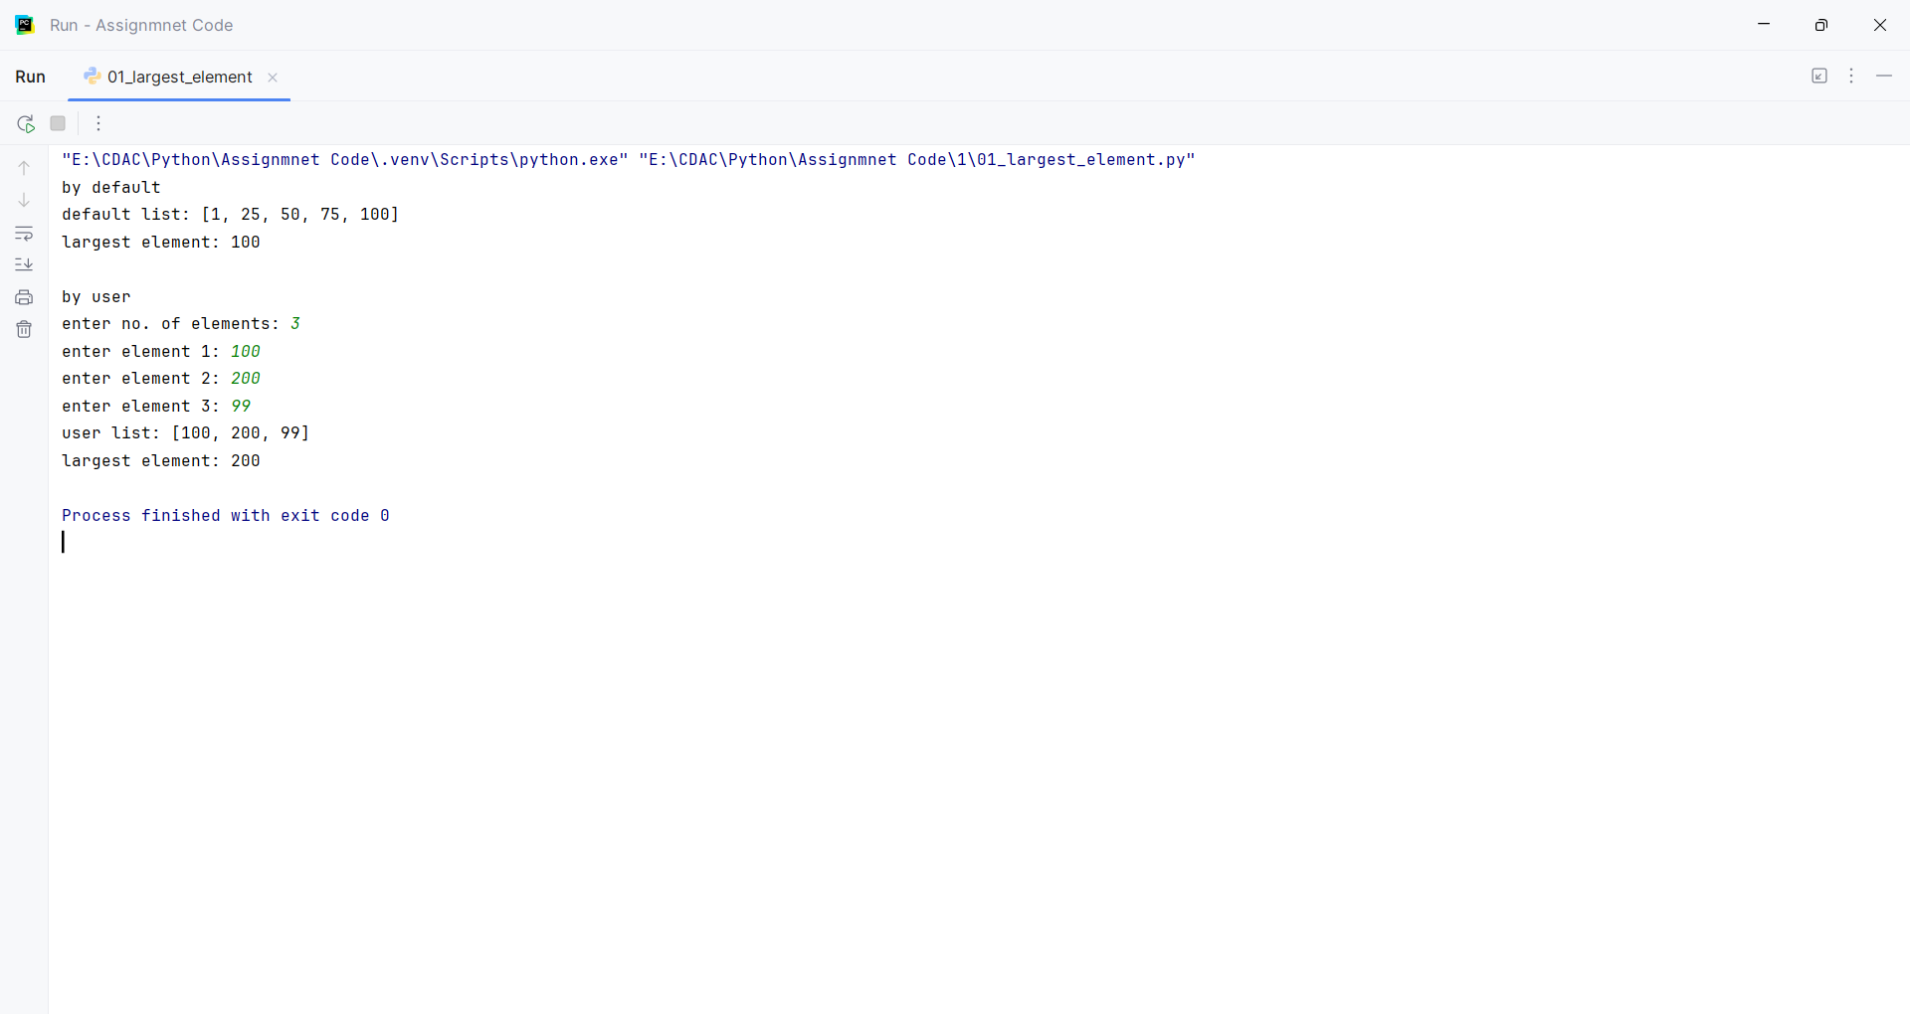
Question:
Find the smallest element in a list.
Program
print('by default')
list1 = [1, 25, 50, 75, 100]
print('default list:', list1)
print('smallest element:', min(list1))
print('\nby user')
list_user = []
n = int(input("enter no. of elements: "))
for i in range(n):
element = int(input(f"enter element {i+1}: "))
list_user.append(element)
print('user list:', list_user)
print('smallest element:', min(list_user))

Input and Output
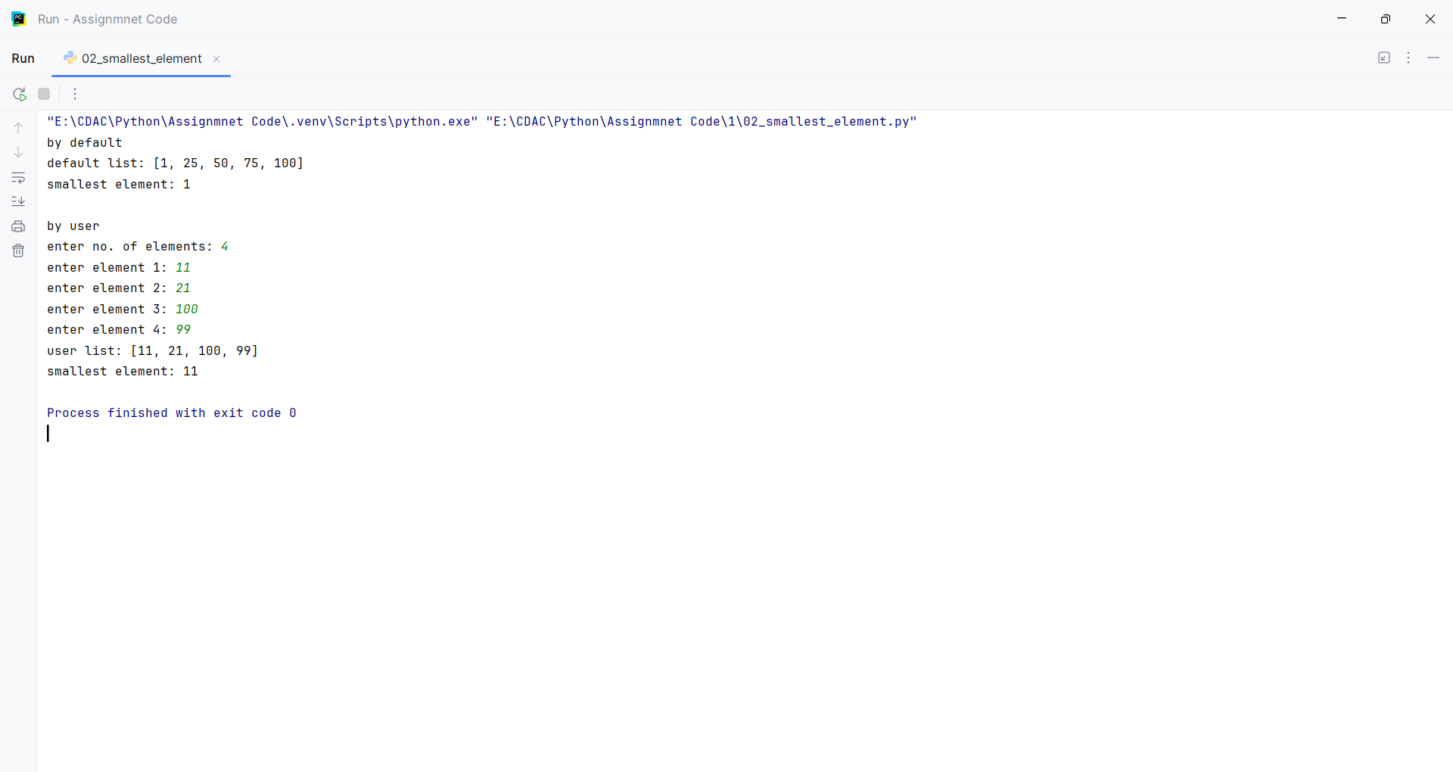
Question:
Remove duplicates from a list.
Program
list1 = [1, 25, 50, 50, 75, 100, 125, 125]
print('original list:', list1)
list_nodup = list(set(list1))
print('no duplicate list:', list_nodup)

Input and Output
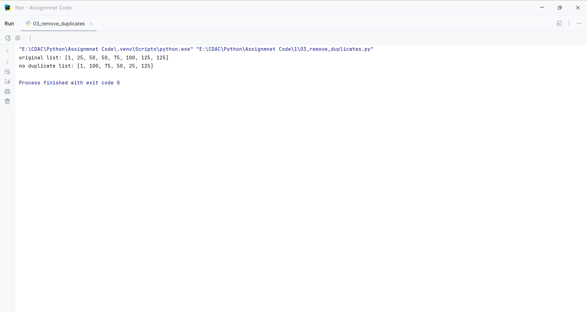
Question:
Reverse a list.
Program
list1 = [1, 25, 50, 50, 75, 100, 125, 125]
print('original list:', list1)
list_rev = list1.copy()
list_rev.reverse()
print('reversed list:', list_rev)

Input and Output
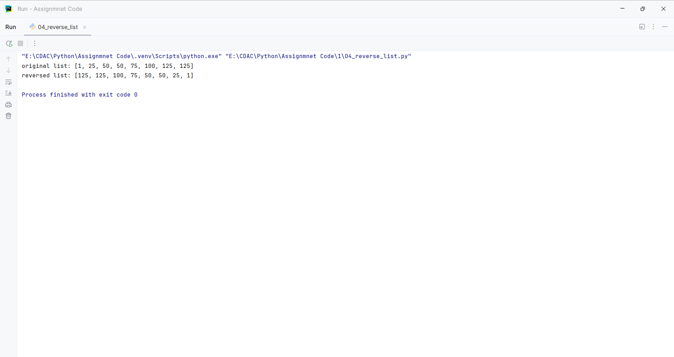
Question:
Find the sum of all elements in a list.
Program
print('by default')
list1 = [45,25,50,85,75,85,100,92,61]
print('default list:', list1)
print('sum of all elements:', sum(list1))
print('\nby user')
list_user = []
n = int(input("enter no. of elements: "))
for i in range(n):
element = int(input(f"enter element {i+1}: "))
list_user.append(element)
print('user list:', list_user)
print('sum of all elements:', sum(list_user))

Input and Output
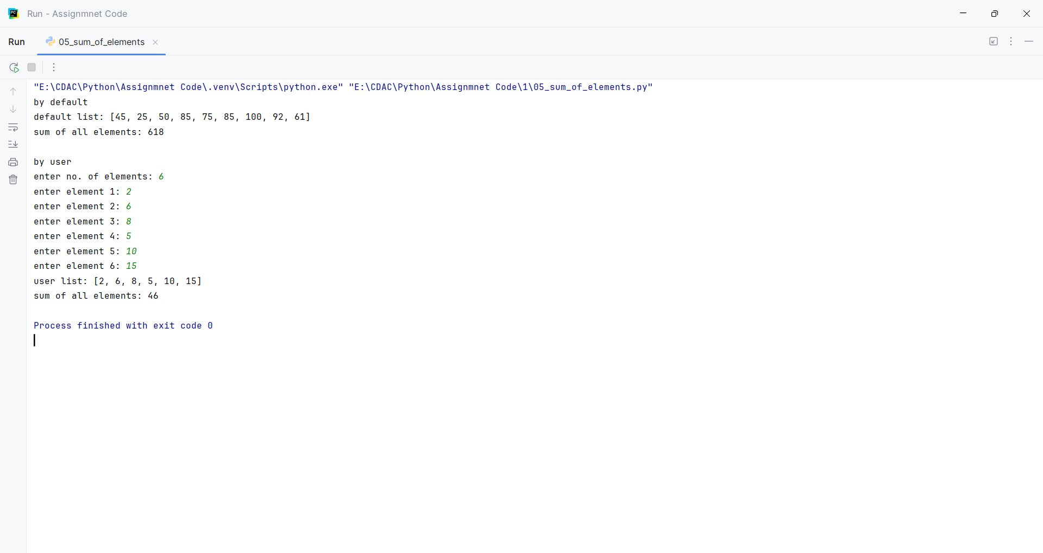
Question:
Find the second largest number in a list.
Program
list1 = [45,25,50,85,75,85,100,92,61]
print('original list:',list1)
list2 = list(set(list1))
list2.sort()
print('no duplicate list:',list2)
second_large = list2[-2]
print("second largest no.:", second_large)

Input and Output
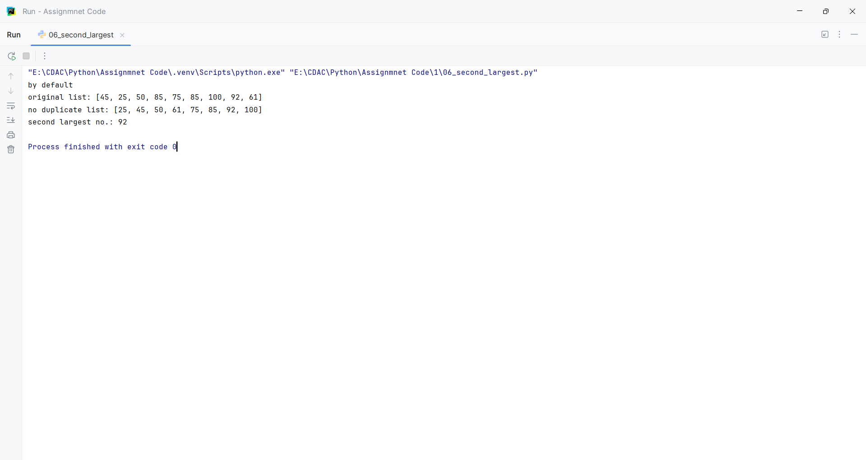
Question:
Count how many times an element appears in a list.
Program
list1 = [10,25,99,36,45,99,54,69,99,72,82,99,100,99]
print('original list:', list1)
list1.sort()
print('sorted list:', list1)
count_no = list1.count(99)
print('count of 99:', count_no)

Input and Output
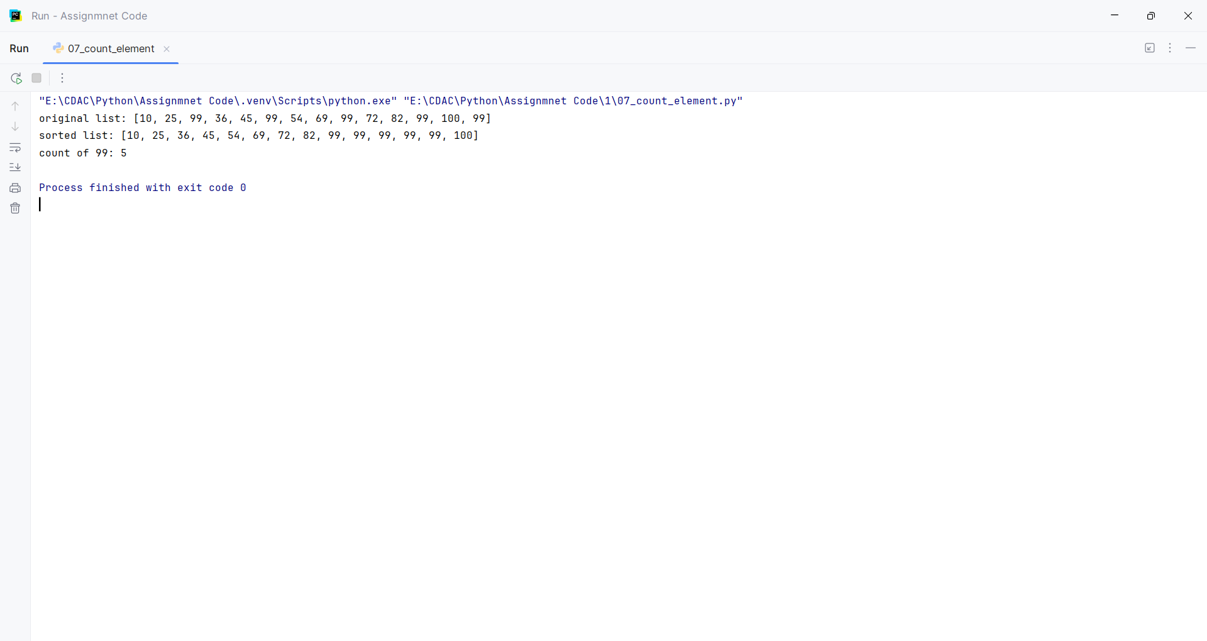
Question:
Merge two lists into one.
Program
print('by default')
list1 = [5,10,15,20,25]
print('list1:', list1)
list2 = [10,20,30,40,50]
print('list2:', list2)
list_merge = list1 + list2
list_merge.sort()
print('merge list:',list_merge)

Input and Output
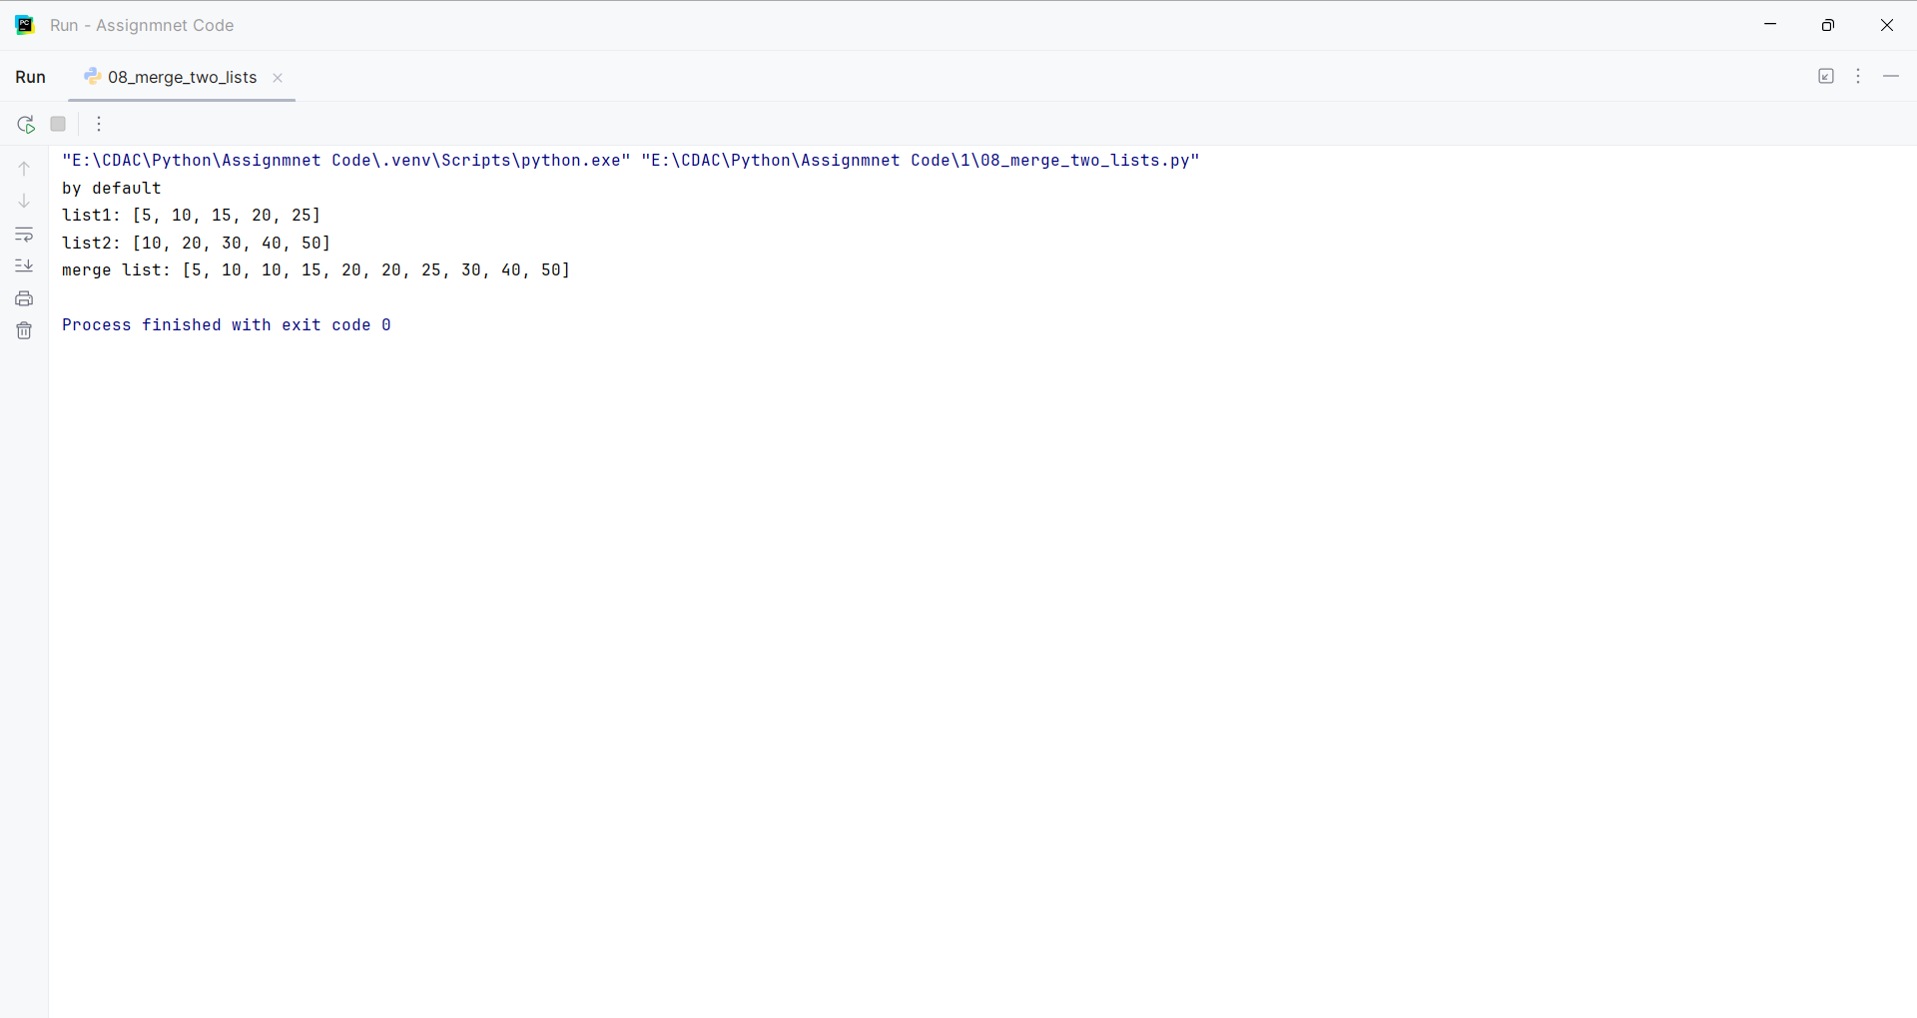
Question:
Sort a list in ascending and descending order.
Program
list=[]
print('by default')
list1 = [5,10,15,20,25]
print('original list:', list1)
list1.sort()
print('ascending order:',list1[::1])
print('descending order:',list1[::-1])
print('\nby user')
list_user = []
n = int(input("enter no. of elements: "))
for i in range(n):
element = int(input(f"enter element {i+1}: "))
list_user.append(element)
print('original list:', list_user)
list_user.sort()
print('ascending order:',list_user[::1])
print('descending order:',list_user[::-1])

Input and Output
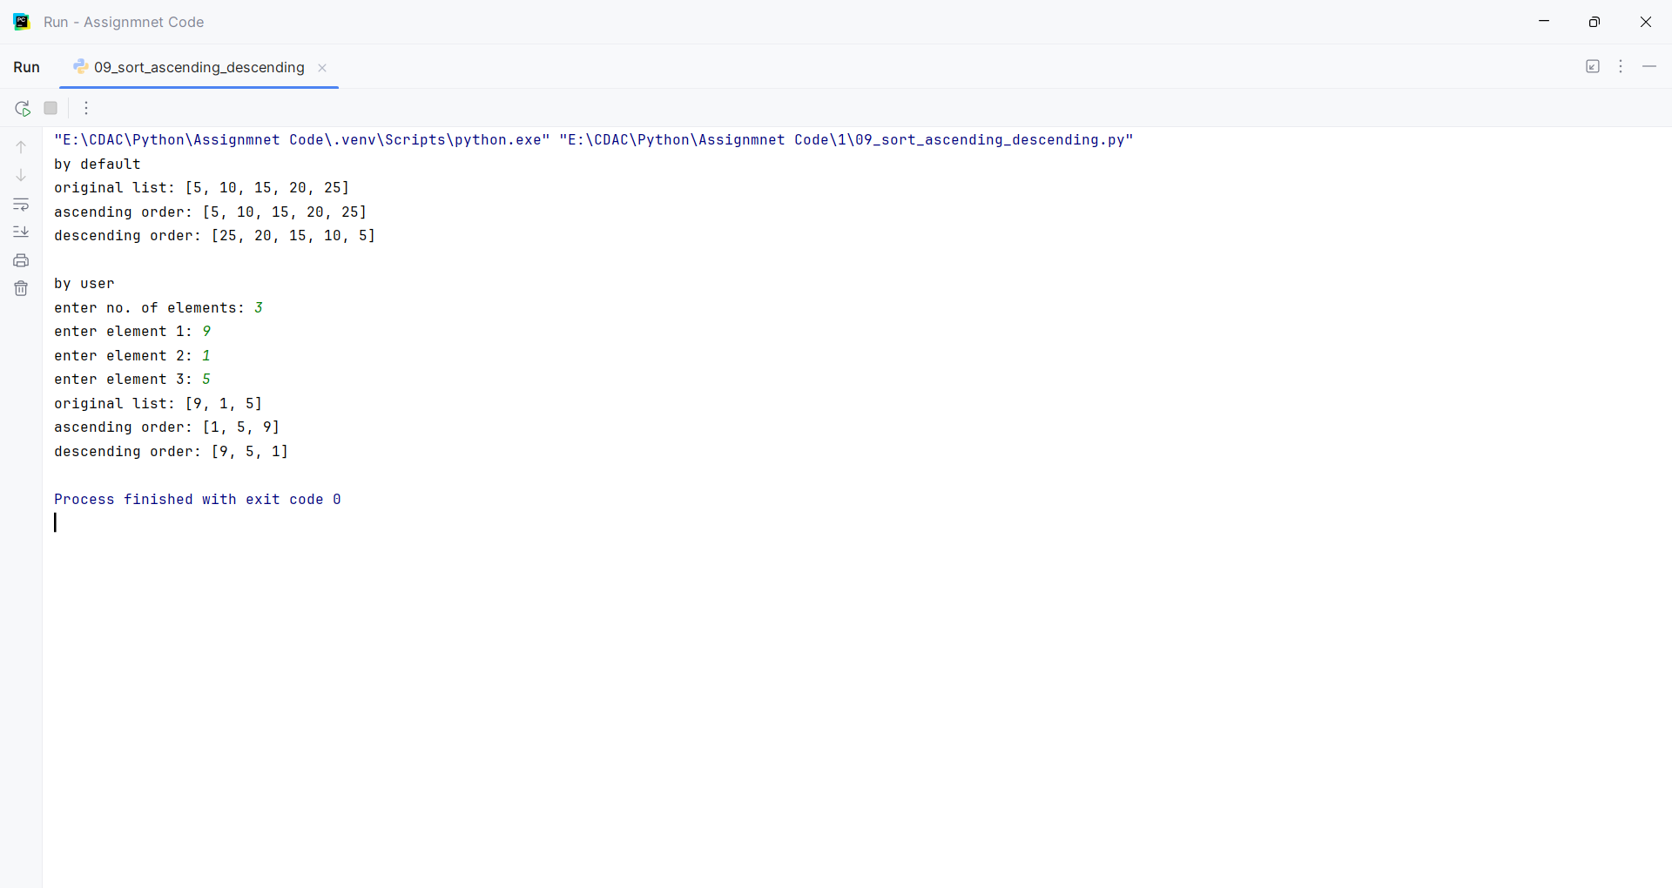
Question:
Create a new list with squares of all elements.
Program
list=[]
print('by default')
list_no = [1, 2, 3, 4, 5]
list_sq = []
for i in list_no:
list_sq.append(i*i)
print('no of list:',list_no)
print('square no of list:',list_sq)
print('\nby user')
list_user = []
list_sq_user = []
n = int(input("enter no. of elements: "))
for i in range(n):
element = int(input(f"enter element {i+1}: "))
list_user.append(element)
for i in list_user:
list_sq_user.append(i*i)
print('no of list:',list_user)
print('square no of list:',list_sq_user)

Input and Output
